AI Use Declaration Form
Course: Introduction to Artificial Intelligence
Lab Title: Lab 2 — Predictive Analysis with Machine Learning
Student Name: __________Oluwademilade Subair_______________________________
Student ID: _____________58742028______________________________________
GitHub Repository Link: __https://github.com/jupiterbouncer/Subair_Oluwademilade_Lab2__
Date Submitted: ___________3rd July 2026________________________________

1. AI Use Summary
Question | Student Response
Did you use any AI tool for this lab? | Yes
Estimated percentage of the work influenced by AI | 12 %
Did you attach evidence of AI use where applicable? | Yes

2. Details of AI Use
Complete the table below for each AI tool used. Add more rows where necessary.
Name of AI Tool Used | Purpose for Using the Tool | Prompt or Instruction Given to the Tool | Part(s) of the Work Influenced by the Tool | How I Verified, Edited, or Improved the AI Output
Claude | Clarifying the meaning/interpretations of certain results and graphs | “how is the confusion matrix interpreted” | Confusion Matrix - Section 2 & Cross Tab - Section 3 | Already had knowledge of the matrix
Claude | Suggesting a classifier to use for a section and why (aside from it being the one provided in the comment) | “why random forest classifier” | Logistic Regressor and Random Forest - Section 2 | Implemented both classifiers and eventually saw the one with a better train-test gap
Claude | Advice on pre-processing and hyperparameters | “which hyper parameter would be nice to try on section 1” | Section 1 - Pre-processing the tip_amount to remove the skew | Realised the model wouldn't fit because features that might be associated with the relationship were not captured

3. Attachment of AI Output Evidence
Where required, attach evidence of AI use. Tick all that apply. Add more rows where necessary.
Evidence Type | Attached? (Yes, No, N/A) | File Name
AI-generated draft | N/A
Prompt history | N/A
Screenshot of AI interaction | Yes | 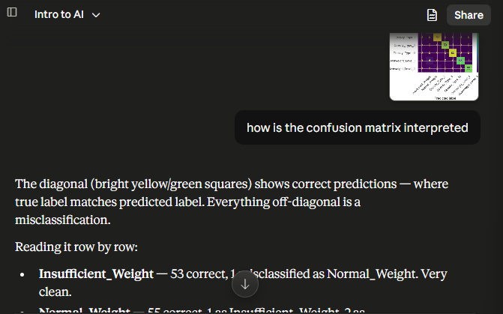  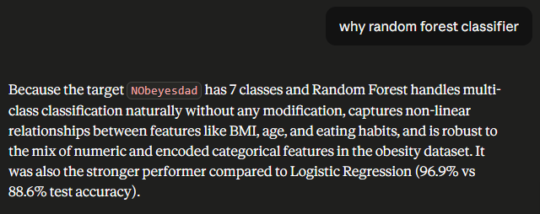  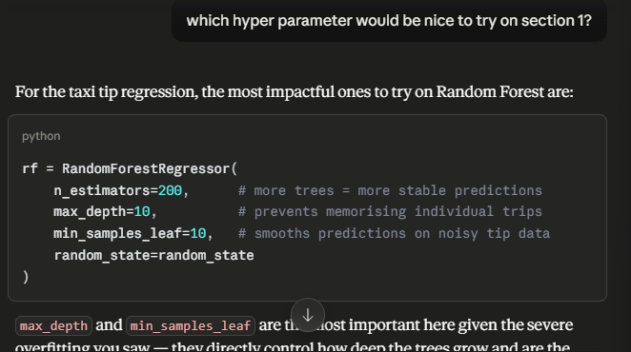
Exported AI conversation | N/A
AI-generated code snippet | N/A
Revised version showing student input | N/A | 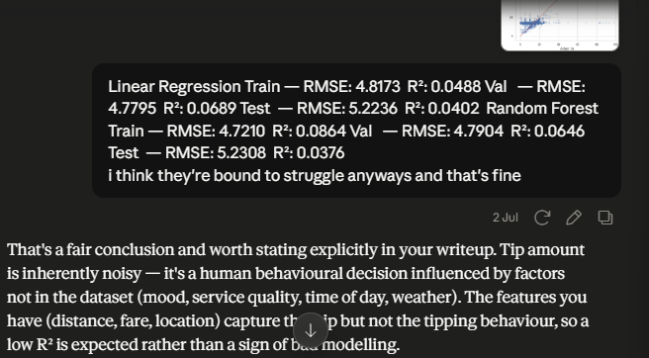

4. Student Declaration
I declare that:
Declaration Statement | Response (Yes/No)
The submitted work is my own work. | Yes
Any use of AI tools has been clearly declared in this form. | Yes
The prompts, instructions, and AI-generated outputs have been disclosed where applicable. | Yes
I reviewed, tested, edited, and improved any AI-generated content before submission. | Yes
My AI usage does not exceed 25% of the entire work. | Yes
I understand that undeclared or excessive AI use may be treated as academic misconduct. | Yes

Student Signature: ___________________________________________
Date: ________________3rd July 2026___________________________

